This document is for faculty & staff of OQEANOUS Plus program.
The outline for
OQEANOUS Plus Short-term Program (STP) 2026

1. Main Theme (Purpose)
We encourage students to take the initiative in learning, discussion, and program design.
Through research-based online sessions and collaborative activities, participants will shape their own OQEANOUS learning experience.

2. Program
① Lecture(Online) (July 21st ~ July 31st)
· Literature study on ocean science and technology
· Hybrid format (collaboration with foreign students, self-study, etc)
·
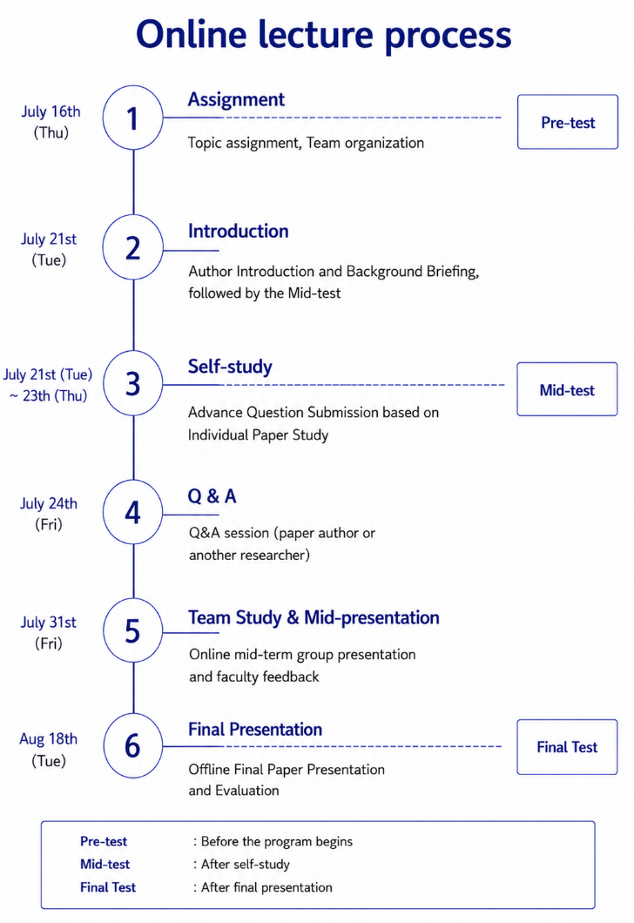
② Activities (Offline) / Aug 12th ~ 18th) (TBD)
- OQEANOUS Introduction with Alumni
. where: KMOU
. what: Introduction and alumni sharing their OQEANOUS experiences
. when: 2nd day
- Field study
. where: National research institute
KIOST(Korea Institute of Ocean Science and Technology) (TBD)
. what: experimental facilities
. when: 3rd day

- Cultural experience
. where: downtown in Busan
Nampo-dong, Yeongdo, etc. (TBD)
. what: experiencing Busan’s local culture
. when: 4,5th day
- OQEANOUS Self-Design presentation
. where: KMOU
. what: group presentation on student-designed ideas for OQEANOUS programs
. when: 6th day
- Final Paper presentation
. where: KMOU
. what: group presentation on the paper and their learning outcomes
. when: 7th day
3. Main attendee
· Senior undergraduate students who are thinking of joining a Master’s course
· Master’s and doctoral course students

4. To-do Schedule
Date | Contents
June 9th (Tue) | Deadline for nomination
June 17th (Wed) | STP 2026 Information session (Online)

5. Financial Support
· Accommodation during the field trip
-KMOU dormitory
-Check-in: Aug 12th(Wed), Check-out: Aug 18th(Tue)
· 1 meal for Welcome party (TBD)
· Transfer between the airport and KMOU campus

6. Confirmation list
· Please complete the confirmation list below and send it back to us by May 25th (Mon)
·
No. | Item to confirm | Response
1 | Availability for the schedule | Full / Partial
 | Available dates (If you choose ‘partial’) | Online:  Offline:
2 | The number of participants(students)  (Recommended: up to 5)
3 | Additional opinion or comments

